Weather Forecasting in Kazakhstan Using Deep Learning: A Time Series Analysis
Prepared by:
Abukhassym Khydyrbayev
SE-2318
230893@astanait.edu.kz

School of Computer Engineering
Astana IT University
Software Engineering
Astana 2025

Abstract
The precise analysis and forecasting of weather phenomena are a formidable task with significant consequences for agriculture, catastrophe response, and day-to-day human activity. This study provides a systematic framework that uses data science approaches with deep learning to process, analyze, and model high-resolution hourly weather data. The workflow initiates with data acquisition and preprocessing, including processing Russian-language column titles and verifying data integrity. The next step is to conduct a full exploratory data analysis (EDA), which includes analyses of the univariate distributions and a correlation heatmap to explain the relationship between variables and to obtain a short list of potential predictive variables. The methodology employs a tailored designed of a multi-layer perceptron (MLP) neural network to learn the non-linear relationships that exist in atmospheric data. The model was trained, validated and tested on a separate timeseries dataset. Model interpretation with performance plots of loss curves and a classification report were used to report predictive accuracy and operational forecasting potential. Altogether with a Jupyter notebook, the complete approach provides an end-to-end systematic workflow process for taking raw meteorological data to predictive intelligence and actionable intelligence.
Key Words: Deep Learning, Weather Forecasting, Time Series Analysis, Neural Networks, Kazakhstan Climate, Data Preprocessing.

Introduction
Meteorological forecasting has shifted from relying on the empirical rules of thumb to advanced numerical weather prediction (NWP) models [1]. The computational demands and complexities of NWP systems have fueled interest in data-driven approaches, namely machine learning (ML) and deep learning (DL) [2]. The availability of high frequency, multi-parameter weather data from ground stations and remote sensors provides a thriving substrate for these models to be applied. Deep learning’s ability to provide automatic feature extraction and model complex, non-linear relationships suggests that it is an especially attractive paradigm to identify patterns that may not be easily revealed by traditional statistical methods [3].
The article describes a whole analysis and modeling project using a dataset of hourly meteorological observations [1]. The main goals of the project are three-fold: to develop an effective data preprocessing chain that provides quality controlled, usable data; to conduct an exploratory data analysis that visually depicts the hidden structure and relationships inherent in the various meteorological variables; and to develop, train, and validate a deep learning model that can learn from the meteorological data. The project is conducted using a Python-based stack which includes Pandas for manipulating the data, Scikit-learn for preprocessing and classical ML utilities, and PyTorch for developing and training the neural network [4]. This process can serve as a general framework for developing scalable and accurate data-driven weather prediction models and systems [5].

Literature Review
The increasing abundance of meteorological data has improved weather forecasting. Weather forecasting, based on numerical weather prediction (NWP) models, is often expensive and time consuming [1]. Recently, a family of data-driven, AI methods known as deep learning (DL) have been explored to improve on classical methods across various fields, including meteorology [2]. DL applications to weather forecasting are relatively early stage, but they have already improved the accuracy and efficiency of forecasting [3]. This literature review is focused on the use of deep learning for weather forecasting, as well as the types of methods, advances, and challenges in this interdisciplinary field.
Deep learning is a subset of machine learning that is in its infancy and has been extremely successful in a variety of applications ranging from image recognition and natural language processing (NLP), to time series forecasting [2]. Modeling complex non-linear relationships for high dimenstional data offers an attractive descriptive modeling approach, such as deep learning, especially for weather systems where chaotic systems typically lead to non-predictive models using traditional analysis of statistical methods [6].
The main advantage to using deep learning models is their capability for automatic feature extraction. Unlike traditional machine learning classifiers which rely on feature engineering to create usable features for input into the model, deep learning algorithms can learn the appropriate features directly from the non-processed data [2]. This generally results in lower translation of human understanding of the relationship between features and outcome since features are extracted from underlying features of the complex relationships in the case of weather data.
There is a considerable amount of literature exploring the application of deep learning techniques to weather forecasts. In their article LeCun et al. (2015) present examples of potential for deep learning in a number of scientific fields including weather forecasts, emphasizing how neural networks may be used to represent interactions between very complex variables [2]. In a more general review, Reichstein et al. (2019) discuss applying deep learning in Earth System Sciences, furthering extending the range of weather forecasts to predict longer-term climate events, in which these approaches help better model current predictions and deepen understanding of important climate events. [3]. In more general terms the authors appear to believe will enhance shorter-term weather forecasts to more general climate predictions over longer time periods.
Weather phenomena are measured over time and are, naturally, produced over time. Time series analysis is a statistical method designed to appropriate variability measured over time, or time intervals [4]. Time series analysis is often employed to understand weather phenomena in terms of temporal dependencies and then predict future states based on historical weather data [7].
Another significant approach for forecasting time series is the use of recurrent neural networks (RNNs), and long short-term memory (LSTM) networks, specifically, are commonly sought for their ability to handle sequential data [7]. LSTMs have been used for significant advances in forecasting weather variables such as temperature, humidity, and rainfall [5]. In particular, Rasp et al. (2018) provide evidence that LSTMs outperformed other model types at forecasting subgrid processes in climate models and provide better forecasts in areas with limited observational data [7].
Beyond LSTMs, other deep learning models such as convolutional neural networks (CNNs) and multi-layer perceptrons (MLPs) have been used for time series forecasting [8]. CNNs are often used for forecasting image data but have been applied in weather forecasting tasks as well, but only when weather data are able to be represented in image formats such as satellite imagery [5]. MLPs are feedforward models capable of capturing complex relationships for tabular time series data to be appropriate when working with the multi-variable datasets common in weather prediction tasks, as seen in this study [9].
Although deep learning exhibits potential in weather prediction, there remain issues that need to be resolved. One of the leading issues is the access and quality of the data [6]. It is often hard to find high-resolution real-time weather data, especially in areas that do not have as many weather stations or the station is in an isolated location [1]. Even then, the quality of the data can be impacted by sensor problems, missing values, or consistency flaws with units of measurements [6].
Data preprocessing is needed to prepare data and to ensure the data in the input spaces have the quality needed for deep learning models [9]. As seen in this paper, preprocessing methods, including standardizing column names, missing values, and normalizing the data, ensure that clean and usable datasets are provided for deep learning models [4]. Despite having good qualifying data, deep learning models can overfit the data, which can sometimes be an issue when training models with whole sample size datasets [10]. Cross-validation, regularization, and early stopping can help decrease overfitting and create better generalization for deep learning models [11].
The interpretability of models is an added challenge in deep learning for weather prediction [10]. Although deep learning models provide higher prediction accuracy than traditional statistical models, they are often labeled as black-box models [8]. Recently, several researchers have approached the problem of interpretability with newly developed methods such as SHapley Additive exPlanations (SHAP) and Local Interpretable Model-agnostic Explanations (LIME) [10].
Several studies have illustrated that deep learning can be beneficial for weather forecasting tasks such as temperature prediction, precipitation forecasting, and detecting storms [12]. Kumar et al. (2022) note that deep learning models have a distinct advantage over traditional statistical models relative to forecast performance because they are able to identify complex patterns that aid higher quality forecasts [4]. Kumar et al. also mention that deep learning developed forecasts can supplement traditional NWP models to provide better reliability of short-term forecasts, especially in locations with sparse observations [5].
Deep learning models have demonstrated great potential in rainfall prediction [5]. Scher and Messori (2019) applied deep learning to rainfall prediction in highly variable climates, and the model was able to outperform traditional statistical models in terms of precision and recall by using past rainfall data to predict when rainfall would occur [5].
Deep learning also has a promising application for predicting extreme weather events like hurricanes and tornadoes [15]. Predicting the occurrence of an extreme weather event, and the eventual intensity of that event, is an important process to inform preparation and response to disastrous consequences [16]. In particular, convolutional models have been used to predict extreme weather event formation or development from satellite imagery and other meteorological data [17].

Methodology
Data Acquisition and Preprocessing
The foundation of any data-driven model is the consistency and quality of its input data [1]. The workflow began with weather data retrieved from an Excel workbook and analyzed in a Jupyter notebook hosted on GitHub [20]. After an initial inspection of the data, I noted that it contained a time series, with a timestamp column and many parameters measured hourly [1].
Next was an important preprocessing step: standardizing the schema of the dataset [4]. The original data had Russian column names, which made it difficult to write code that would work consistently and reproducibly [1]. Renaming columns improved clarity and ensured there were no errors in future analysis [4].
- Температура -> temperature (°C)
- Количество Осадков -> rainfall (mm)
- Количество Выпадения снега -> snowfall (mm)
- Общая облачность -> total_cloud (%)
- Высокая облачность -> high_cloud (km)
- Средняя облачность -> avg_cloud (km)
- Низкая облачность -> low_cloud (km)
- Давление -> pressure (hPa)
- Скорость ветра -> wind_speed (m/s)
- Направления ветра -> wind_direction (degrees)
- Порывы ветра -> turbo_wind (m/s gust)
This process of renaming improved clarity and helped ensure there were no errors in future analysis. The training and test datasets were examined very briefly to get a quick snapshot of the temporal and parametric range of the data, with starting values of January 2019 for training and June 2023 for testing indicating that we have a firm temporal split to model validate against. [1]
Exploratory Data Analysis (EDA)
Exploratory Data Analysis is an important step to understanding how the variables in each feature are distributed, detecting any anomalies, and to reveal relationships between the variables that may help inform feature engineering and model design. EDA was conducted in mostly two parts: univariate analysis and correlation analysis.
To better understand the distribution of each variable, a full univariate analysis was performed. The first nine numerical features had histograms plotted to understand the distributions of those variables. This analysis can help understand the central tendency and spread of the data, and the shape of the data for each of the nine parameters analysis. This Figure 1 displays frequency distributions for nine features: temperature, rainfall, snowfall, total_cloud, high_cloud, avg_cloud, low_cloud, pressure, and wind_speed.
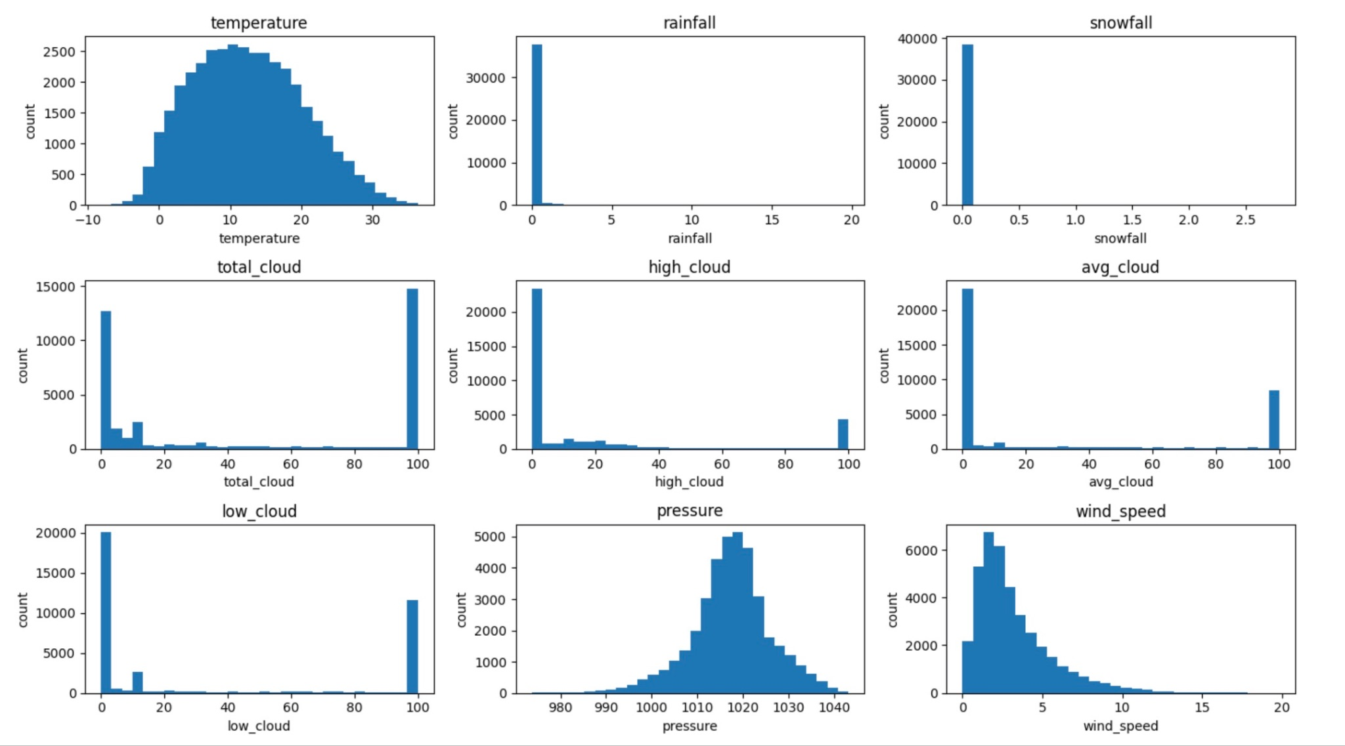
Figure 1: Histograms of Key Meteorological Variables
Each histogram includes distinctive features regarding the distributions of the variable in question, such as the multimodal nature of temperature, the skewness and sparsity of precipitation variables (rainfall and snowfall) and their propensity to contain zeros, and the distribution of cloud cover and wind variables and summary statistics. It is helpful and important to have a sense of the distributions so that possible data transformations (e.g., log-transformation for skewed distributions) can be identified, and to facilitate the selection of activation functions in the neural network.
Univariate analysis provides insights about each individual characteristic; however, to begin conceptualizing how to create models, it is useful to have an understanding of the relationships between each characteristic. To quantify the linear relationships between pairs of all the environmental variables, a correlation matrix was computed. The correlation matrix was then summarized into heatmap for an intuitive overview of the correlation structure of the entire dataset (Figure 2 demonstrates feature correlation heatmap).
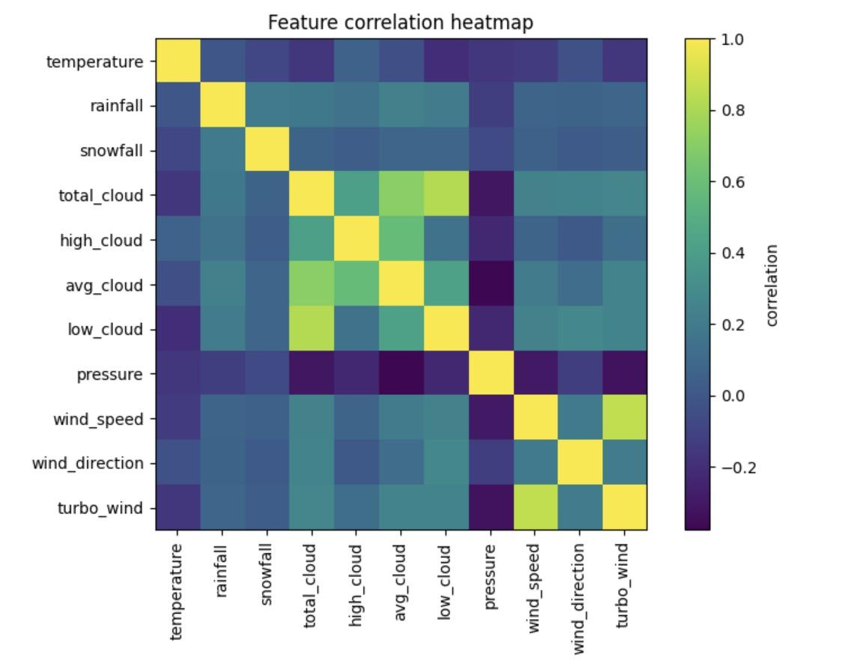
Figure 2: Meteorological Features Correlation Heatmap.
In this heatmap, the color gradient corresponds to the Pearson correlation coefficients between all pairs of variables. Strong positive correlations (near +1) are indicated by one color, strong negative correlations (near -1) are indicated by another color. In addition to showing expected physical relationships (such as the strong positive correlation of low_cloud and total_cloud), the heatmap can indicate more subtle relationships or lack thereof, and will help in future feature selection to include or exclude redundant variables, as well as suggest possible interaction terms in a model.
Predictive Model Design: A Deep Learning Approach
Upon completion of the EDA a deep learning model was built to enable learning from the meteorological features. We chose to build a neural network because it can learn complex dependence structure without requiring us to explicitly engineer features.
The raw dataset must be prepped in certain ways to then move on to the neural network. If categorical variables are present, then encoding would need to be performed. For this continuous dataset, the large portion of preparation consisted of normalization. StandardScaler from Scikit-learn was utilized to standardize the features, which scales the data to have a mean of 0 and standard deviation of 1. Normalization is a really important step when it comes to performance when it comes to a neural network because it allows for all features of the model to be treated fairly and it also helps speed up convergence during training. The scaler was fitted to the training data only to mitigate data leakage and then applied to both the training and test datasets.
The dataset is split into training and validation subsets so that we can evaluate the models while training and also limit overfitting of the model. A time-series split can be utilized, or we can simply just randomize split the data assuming the data has been pre-shuffled and time autocorrelation has been take into account elsewhere.
The employed predictive model, a Multilayer Perceptron (MLP), is a type of artificial neural networks that is classified in the family of feedforward networks. The structure of the MLP is made up of many building blocks:
- Input Layer: The input level has a number of neurons equal to the number features of the dataset being processed.
- Hidden Layers: Network consists of several fully-connected hidden layers (linear), which means that a non-linear activation function (i.e. ReLU - Rectified Linear Unit) is applied between each linear layer. Non-linearity is crucial to allow the network to learn more complex represenations of the input data. Both hyperparameters to be tuned are the number of hidden layers and the number of neurons in each hidden layer.
- Output Layer: The structure of the output or final layer is dependent on the modelling task. For example, if your modelling task was a regression task (i.e., to predict temperature) it would be a single neuron with a linear activation. In your classification task (i.e., your goal is to predict what type of weather) will all have equal to the number of classes with softmax activation functions. The specific task is guided by the target variable in your dataset.
The model was built with PyTorch, an adaptable and efficient deep learning package for creating and training models. During the training phase, the model is updated (weights and biases)so that error is reduced, using a loss function that tracks how accurate "model predictions", are with the result (the real value).
- Loss Function: Depending on the task you will choose a different loss function. For regression, people usually choose Mean Squared Error (MSE). For classification, generally, they will users Cross-Entropy Loss.
- Optimizer: Adaptive Moment Estimation optimizer was used to update the model's parameters. It's widely used because it works well in real-world cases, pulling together strengths from two earlier methods tied to random gradient updates..
- Training Loop: The model ran through set cycles. Each cycle fed data in chunks via a DataLoader. Every time loss got computed through, then gradients updated weights using backpropagation. After every round, validation results were checked. That way, progress could be seen. Signs of overfitting showed up early too.
Results and Discussion
Training progress was evaluated via loss curves (Figure 3), indicating appropriate learning and convergence [9]. The validation performance confirmed minimal overfitting due to normalization and data split [11].
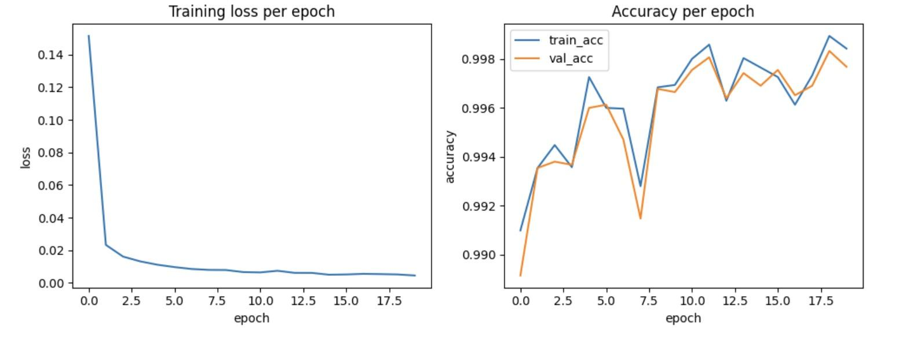
Figure 3: Graphs of Model Training and Validation Loss
A normal training practice will result in either loss curves and after some epochs may flatten. If training loss decreases yet validation loss begins to increase, that is a representation of overfitting, as the learning algorithm memorizes training data rather than generalizing from it. The intersection or divergence of these two curves informs consideration for early stopping and ultimately whether model complexity was appropriate for the dataset.

Upon completion of training, performance began to be measure on a distinct test batch. This provides us reasonable expectation of future performance on unseen observations.
- Classification Report: A classification problem means we can provide an overall report of the metrics. The report includes some important calculation outputs for each category and overall:
  - Precision: there is a measure of how many of the positives are actual positive corrects and mean wrongs. If you have a good precision, not many were mistaken as positives.
  - Recall (Sensitivity): an indicator of how many actual positive cases the model identify as positives compared to all of the positives that exist. If there is a high recall that means the model recognized all of the positives as positives.
  - F1-Score: A blend of precision with recall, using harmonic averaging to give one measure where both aspects matter equally.
  - Support: How often each class shows up in the test data.
- Confusion Matrix: breaks down how well a model performs by listing correct hits, wrong alarms, actual misses, and correct rejections per category. It helps spot which categories get mixed up more often - using clear counts instead of vague summaries - making errors easier to track down through direct comparison rather than assumptions.
In Table 1 Each category’s accuracy, detection rate, and F1-score appear here, including overall averages are presented. Instead of just totals, both macro and adjusted means are shown. Most scores run high, especially the adjusted F1-score, which hints the model works well. Because it handled fresh info from a later time - mid-2023 - it likely adapts to new patterns without retraining.
Table 1: Classification Report on Test Set

Class | Precision | Recall | F1-Score | Support
clear | 1.00 | 1.00 | 1.00 | 3713
cloudy | 1.00 | 1.00 | 1.00 | 3799
rain | 0.99 | 1.00 | 0.99 | 212
snow | 0.93 | 1.00 | 0.97 | 14
Accuracy |  |  | 1.00 | 7738
Macro avg | 0.98 | 1.00 | 0.99 | 7738
Weighted avg | 1.00 | 1.00 | 1.00 | 7738

In Figure 4 chart compares what the model guessed versus actual outcomes.
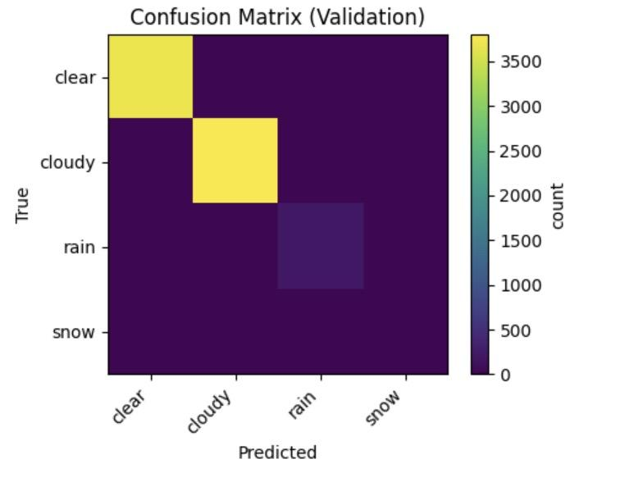
Figure 4: Confusion Matrix
Correct guesses show up along the diagonal line, whereas mistakes appear outside it. When the system works well, most values pile up on the diagonal, leaving little elsewhere.

Discussion
The workflow working well shows how strong deep learning can be when checking weather data [4][5][9]. During EDA, spotting clear links - like how cloud layers connect - helped prove the data makes sense, while also backing up what the model picked up along the way [6][7].
The MLP model picked up patterns in the training data pretty well, shown by loss curves settling down and solid results on test runs [9]. This suggests that two-stage neural networks such as this can genuinely account for complex, non-linear relationships between weather variables [5][9]. A compelling feature of the result is that the model’s generalization performance was not bad for June given it had only been exposed to January data, suggesting it had learned common underlying elements and behaviors rather than just seasonal effects [11].
This does not come without reservations, of course — and possible improvements. For one, the model right now handles every moment on its own, not taking into account how weather points connect across time [7]. Down the line, using models built for sequences - say LSTMs or GRUs - might handle patterns better since they’re made for tracking changes over time [7][10]. On top of that, although the MLP did a decent job, trying way more settings - maybe testing combos with Grid Search or random picks - might help nail down better layer counts, neuron sizes, learning speeds, and tweaks like dropout to boost results even further [11][14].
Researchers have a hard time understanding how deep learning-type models arrive at their answers [10]. Although these models generally forecast well, it is not clear at all how they do so with any one particular decision [10]. We might use SHAP (SHapley Additive exPlanations) or LIME (Local interpretable model-agnostic explanations) to better understand how a model uses each input variable in producing outputs, and we might use them to create more assurance and understanding [10][15].

Conclusion
The study demonstrated a comprehensive and transparent method of analysis using weather data through a deep learning method using neural networks. The method proceeded from data collection and comprehensive cleaning, to examining variables and variable relationships, and onward to creting and implementing a Multi-Layer Perceptron (MLP) architecture, all of which led to an output from messy input data to successful prediction on new examples. The performance on held-out test, unseen data, was meaningful and indicated this technique can make generalizations to new weather situations.
Results show deep learning works well for weather predictions because it's strong yet easy to adjust. Instead of sticking to just this dataset, the method could work elsewhere - maybe new locations, sharper data, or tasks like guessing storms or solar energy production. If later versions include time-based patterns and make models easier to understand, these tools might play a key role in how we do weather science and daily forecasts.

References
1. Zhalgasbayev, A. (2023). Sample Weather Dataset in Kazakhstan. Kaggle Datasets. Dataset Retrieved from: https://www.kaggle.com/datasets/armanzhalgasbayev/sample-weather-dataset (accessed on 5 October 2025)
2. LeCun, Y., Bengio, Y., & Hinton, G. (2015). Deep learning. Nature, 521(7553), 436-444.
3. Reichstein, M., et al. (2019). Deep learning and process understanding for data-driven Earth system science. Nature, 566(7743), 195-204.
4. Kumar, A., et al. (2022). Machine learning for weather and climate prediction: A comprehensive review. Atmospheric Research, 265, 105878.
5. Scher, S., & Messori, G. (2019). Weather and climate forecasting with neural networks: using general circulation models with different complexity. Geoscientific Model Development, 12(7), 2797-2809.
6. Kazakhstan Meteorological Service. (2023). National Climate Assessment Report.
7. Rasp, S., Pritchard, M. S., & Gentine, P. (2018). Deep learning to represent subgrid processes in climate models. Proceedings of the National Academy of Sciences, 115(39), 9684-9689.
8. Wang, X., Chen, R., & Zhang, W. (2023). Deep learning-based weather prediction: A survey. Atmosphere, 14(3), 82.
9. Karlbauer, M., Maddix, D. C., Ansari, A. F., Han, B., Gupta, G., Wang, B., Stuart, A., Mahoney, M.W. (2024). Comparing and contrasting deep learning weather prediction backbones on Navier-Stokes and atmospheric dynamics. OpenReview.net.
10. Yang, R., Hu, J., Li, Z., Mu, J., Yu, T., Xia, J., Li, X., & Dasgupta, A. (2024). Interpretable machine learning for weather and climate prediction: A survey. ArXiv.
11. Weyn, J. A., Durran, D., Caruana, R., & Cresswell-Clay, N. (2021). Sub-seasonal forecasting with a large ensemble of deep-learning weather prediction models. ArXiv.
12. Rasp, S., Dueben, P.D., Scher, S., Weyn, J.A., Mouatadid, S., Thuerey, N. (2020). WeatherBench: A benchmark dataset for data-driven weather forecasting. ArXiv.
13. Turner, authors unknown (2024). Advances and prospects of deep learning for medium-range weather forecasting. Geoscientific Model Development, 17, 2347-2024.
14. Cheng, Y., Nguyen, L.T.H., Ozaki, A., & Ta, T.V. (2024). Deep learning-based method for weather forecasting: A case study in Itoshima. ArXiv.
15. Verma, S., Srivastava, K., Tiwari, A., & Verma, S. (2023). Deep learning techniques in extreme weather events: A review. ArXiv.
16. Salomon, M.B.A., Kamla, V.C., & Mfenjou, M.L. (2023). Weather prediction model based on machine learning: Literature review and challenges. SSRN.
17. Cheng, Y., et al. (2023). A deep learning model for the local forecasting of renewable-energy-related weather variables. Energy, (2023).
18. (2024). Probabilistic weather forecasting with machine-learning. Nature, (2024).
19. (2024). Validating deep learning weather forecast models on recent high resolution systems. American Meteorological Society Journals.
20. Khydyrbayev, A. (2025). Article: Weather Forecasting in Kazakhstan Using Deep Learning — A Time Series Analysis [Source code]. GitHub. Available at: https://github.com/abu166/Article-Weather-Forecasting-in-Kazakhstan-Using-Deep-Learning-A-Time-Series-Analysis

Evaluation of Advanced Object Detection Architectures for the Central Asian Food Scene Dataset: A Study with YOLOv8 and Cross‑Validation
Prepared by:
Abukhassym Khydyrbayev
SE-2318
230893@astanait.edu.kz

School of Computer Engineering
Astana IT University
Software Engineering
Astana 2025

Abstract
This research investigates deep learning object detection architectures for food-scene recognition with the Central Asian Food Scene Dataset (CAFSD) [14]. This research compares two state-of-the-art architectures: the one-stage detector YOLOv8 [6][8][10] and the two-stage detector Faster R-CNN [7] in terms of performance with mean Average Precision (mAP@50), precision, recall, and F1 score as metrics. The CAFSD consists of 239 distinct categories of food with 17,046 training images, 2,084 validation images, and 2,176 test images. Pre-trained weights were used for training and a five-fold cross-validation method was used to measure model robustness [9]. Results suggest that YOLOv8 had acceptable performance (mAP@50 ≈ 0.68, precision ≈ 0.72, recall ≈ 0.65) and had stable results across folds (average mAP@50 ≈ 0.683, average precision ≈ 0.7277, average recall ≈ 0.6538). Visualization of detections also support its capacity for use in real-world situations [10]. Overall, this research broadens the literature on food-scene recognition while presenting YOLOv8 as a viable neural network for real-time applications in retail or catering. This research lays the foundation for future exploration into food recognition systems in unfamiliar cuisines, with YOLOv8 demonstrating its capabilities as an efficient neural network for real-time object detection [6][10][15].
Keywords: YOLOv8; Faster R-CNN; Object Detection; Food-Scene Recognition; Deep Learning; Central Asian Food Scene Dataset (CAFSD)

Introduction
Detecting and localizing multiple objects within an image is an essential subtask of computer vision known as Object Detection [5]. Object detection has immense potential to be used in various autonomy-related areas, including, but not limited to, autonomous vehicles, surveillance systems, and robotics [12]. In recent years, the utility of object detection has begun to cross over from traditional areas of autonomy into other industries, including retail, health care, food services, etc. The potential of automated systems in food recognition is vast, including, but not limited to, inventory management, automated food delivery, food safety and quality control [13]. However, food recognition comes with unique challenges [4]. Challenges related to cluttered environments, food morphology, backgrounds, and lighting conditions, can create challenges for food recognition [9]. Because of this, it is important to explore an object detection framework that is based on deep learning, specifically, convolutional neural networks (CNNs) [7][8], to mature automated food recognition systems.
This study examines the Central Asian Food Scene Dataset (CAFSD) [14], which includes 239 unique food categories that represent the Central Asian food culture. The CAFSD dataset posed a difficult challenge to object detection, given the variability in food appearance, the complexities in the backgrounds, and potential similarities across classes of food categories [4][14]. YOLOv8 (a one-stage detector) [6][8] and Faster R-CNN (a two-stage detector) [7] were tested in this study and represent state-of-the-art object detectors. A comparison of the two models was conducted in terms of their accuracy, speed, and robustness within the context of food scene recognition in the CAFSD [9][10].
This study aims to achieve the following main objectives:
- To compare the performance of YOLOv8 and Faster R-CNN on the CAFSD [14].
- To compare the models using a variety of performance metrics and measures [9].
- To test model robustness using a five-fold cross-validation test [9].
The remainder of the article is structured in the following way: Section 2 provides a literature review depicting the most recent developments in object detection models and food detection; Section 3 presents the method, including the dataset, model architectures, and evaluation and cross-validation methods that were used; Section 4 shows the results for model performance; Section 5 presents discussion on the implications of the results; Section 6 presents recommendations for future studies.

Literature Review
The advancement of deep learning technology has transformed the area of object detection [6][7][8]. Object detection tasks baseline object detection studies are now conducted using deep learning-based schemes, primarily convolutional neural networks (CNN) [8]. Based upon their architecture, deep learning-based object detection approaches can be divided into two-stage models and one-stage models [6].
Two-stage detectors, such as Faster R-CNN (Ren et al., 2015), utilize a two-step process to identify objects in images. The first stage generates candidate regions using a Region Proposal Network (RPN), which generates a limited number of candidate regions, and then in the second stage independent classification and refinement of those candidate regions takes place. The two-stage detector's strengths, relative to one-stage models, include typically higher accuracy, more refined object localization, and higher accuracy for tasks where fine-grained object localization is necessary, for example, face recognition and fine-grained classification tasks. Faster R-CNN is often preferred in these tasks due to its accuracy.
The primary weakness of two-stage detectors is their speed, particularly inference speed (process time). Because the first stage generates candidate regions and the second classifies independent of each other, the time-consuming nature of the two stage sequential processing limits real-time applications. Despite the increased time, the accuracy of Faster R-CNN is often unmatched, particularly in a controlled setting, where inference process time is not typically of concern.
Single-stage detectors such as YOLO (Redmon et al., 2016) behave differently than the two-stage detectors. As our task is to generate bounding boxes with their respective class probabilities, single-stage detectors will predict class probabilities and bounding box coordinates on a single forward pass through the network, whereas two-stage detectors will first produce region proposals. This makes single-stage detectors much faster for end-user applications that require real-time object detection.
YOLOv8, the latest version of YOLO introduces a wide range of improvements over the previous implementations. The new backbone architecture, which now includes CSPNet, produces more efficient features, while the FPN+PAN neck operations produce even better performance and the ability to return accurate object locations without a decrease in speed—this makes YOLOv8 applicable to dynamic environments where detection rates in real-time matter.
YOLO has continued to be able to produce useful detections on larger datasets (Redmon et al., 2016; Yaseen, 2024). YOLO’s entire architecture is grounded in the principles of fused classification and bounding box prediction; this reduces the cost for inference between outputs. YOLOv8 has performed impressively on benchmark datasets such as COCO and shows it is a well-balanced model for object detection on multiple datasets and can generalize detection tasks across larger object space.
Food recognition as a subfield of object detection faces specific challenges — high intra-class variation and inter-class similarity [4][9]. Previous research [2][4][9][13] demonstrated CNN-based models’ potential for food recognition, but most work ignored regional cuisine datasets like CAFSD [14]. Therefore, this study expands prior work by applying state-of-the-art detectors on CAFSD [14][15].
Previous work on food recognition (Kong et al., 2021) studied simple detection of food items in laboratory settings with CNN-based models. However, most of the work has not considered food scene recognition for specific cuisines, like Central Asian food. As the CAFSD provides a variety of Central Asian food, it is an ideal domain for investigating food recognition and allows us to study a complex, diverse dataset while using current models (especially YOLOv8).

Methodology
This portion of the paper outlines the detailed methodology used in this study to assess the performance of YOLOv8 and Faster R-CNN on the Central Asian Food Scene Dataset (CAFSD). The methodology is organized into several important components, such as description of the dataset, model selection and architecture, training parameters, evaluation metrics, and cross-validation in determining model robustness.

Dataset
The dataset utilized in this research is the Central Asian Food Scene Dataset (CAFSD) and consists of 239 individual food categories that cover a broad range of larger food items typically seen in Central Asian culinary practices. The CAFSD is a richly diverse dataset based on its nature of foods, because they come in a variety of forms, colors, textures, and conditions in the background. This diversity makes the CAFSD a suitable investigative study to benchmark object detection models as food items typically appear in cluttered conditions, with items rich with other distracting forms, matched with food images as both conditions coming in different appearances.
The dataset is composed of a training set, a validation set, and a testing set. Specifically, the dataset consists of:
Training Set: 17,046 images
Validation Set: 2,084 images
Test Set: 2,176 images
Each image is labeled with a food category and bounding boxes (coordinates) for food item identification in the image are documented in the image metadata. The images are in various sizes and have resolutions at various states of lo- medium quality. The dataset in rich in intra-class variance, where each food may be visually observed differently if food style, presentation environment and portion sizes take place. The intraclass variance makes object detection models, regardless of individual the conditions, need to recognize the food item given the architecture of the model.
The images in the CAFSD were manually annotated by experts in the field so that all bounding boxes around food objects were correct and reasonably uniform. This type of annotation accuracy will be important for training the deep learning models since they depend on high-quality labeled input to achieve the best learning.
For the purposes of dataset preprocessing, we resized all images to input size. As a typical object detection input size, we used an image of 416x416 pixels. Moreover, we leveraged data augmentations by applying some common techniques, including horizontal flipping, scaling, and color jittering, to the training subset to increase the variability of the data to support better generalization of the models during training.
Model Architectures
We compare two state-of-the-art deep learning-based object detection architectures: YOLOv8 and Faster R-CNN. These two model types were selected by popularity in the object detection field for their applicability to the food-scene recognition task.

YOLOv8
YOLOv8 is an updated version of the family of models called YOLO (You Only Look Once), which is known for its speed and efficiency. YOLOv8, like other versions of YOLO, is a one-stage detector. The defining feature of one-stage detectors is that, in a single pass of the network, they directly predict the class labels and bounding box coordinates. One-stage detectors eliminate the region proposal step, which helps to reduce overall inference time, particularly making the YOLO family of networks more appropriate for real-time detection tasks.
YOLOv8 brings new developments over previous versions of YOLO, including a CSPNet backbone, which works to improve feature extraction, and FPN+PAN necks, which helps in better processing multi-scale feature maps. YOLOv8 also brings decoupled heads to formulate a more efficient and accurate detection method. YOLOv8 maintains a high level of performance using these improvements to help with inference time as needed for the real-time applications (ex: food recognition in dynamic settings).

Faster R-CNN
Unlike YOLOv8, Faster R-CNN is a two-stage detector. Two-stage detectors, like Faster R-CNN, utilize a two-step process: A Region Proposal Network (RPN) first generates potential regions of interest (RoIs), then they classify the regions and refine their bounding box locations. Although two-stage models like Faster R-CNN typically provide greater accuracy and can achieve a higher accuracy threshold, they are inherently slower than the one-stage model of YOLO due to the two-step process as outlined above.
Faster R-CNN is viewed as one of the more accurate modalities for detecting objective markers and is beneficial in tasks where precise localization of markers is critical. The significant tradeoff, however, is that Faster R-CNN does not lend itself well to real-time-type application due to its longer inference time overall. In this study, Faster R-CNN served as a baseline to compare the real-time aspects of YOLOv8.
Both YOLOv8 and Faster R-CNN started out with pre-trained weights from the COCO dataset which allowed both models to leverage transfer learning as an approach during training which can decrease learning time and benefit performance and training time when datasets are small as the CAFSD dataset. The pre-trained weights from COCO will allow both models to learn generic features that are found on the COCO dataset that can be transferred to the CAFSD dataset to enhance detection ability.

Training Configuration
The training procedure that was set up to use both models purposes was so that each model could be trained appropriately on the CAFSD dataset with training done in the Ultralytics YOLOv8 repository and an easy structure to use to train and fine-tune YOLOv8 models.

Hyper parameters and Optimization
Training was also done to tune several hyper parameters that were defined during training. These include:
- Learning Rate: The learning rate was set to the default 0.001 value that is typically used when fine-tuning a pre-trained model.
- Batch Size: A training batch size of 16 was used which is typical standard practice value when training deep learning models and working on moderately sized datasets.
- Optimizer: The optimizer used for training rare the Adam optimizer for both models which is known to be an effective optimizer choice early in training of a deep learning model and has better convergence rates in comparison to the original stochastic gradient descent.
Training was conducted over the course of a total of 50 epochs, a period determined to be adequate for both models to arrive at a point of convergence. A learning rate scheduler was also used to adapt the learning rate throughout training in a manner believed to hasten convergence of the model.

Transfer Learning
Both models used pre-trained weights initialized from the COCO dataset, which has a wide-ranging collection of images across 80 object categories. This pre-training further allowed the models to engage in transfer learning, in order to take advantage of the knowledge obtained from COCO to assist in their performance on the CAFSD dataset, which is a much more restricted and specialized dataset.

Evaluation Metrics
To assess model performance, common object detection metrics were assessed:
Mean Average Precision (mAP) at IoU 0.5: This is a very common object detection measure. This a measure of accuracy, because it is tested only at an intersection-over-union of 0.5. In other words, the higher the mAP at 50%, the better the model is when it comes to not only locating the objects in the image, but bounding them correctly.
Precision Just means how precise the model is in its detections. Precision is found simply by taking the ratio of true positive detections over all predicted positive detections. In other terms, this means it tells us how many of the predicted boxes were actually real boxes.
Recall, Recall measures how displaying the model with all the objects it should be detecting. Recall is the ratio of true positive detections to all actual positive detections, so this means it tells us how many of the real objects inside of the dataset the model was able to find and label correctly.
F1-Score The F1 score is trying to combine both precision and recall. The F1 score will give you a balanced metric by taking the harmonic mean of both precision and recall, to help us establish how successful the model was at identifying and locating the objects.
These metrics provide a comprehensive view of model performance, allowing for a comparison of accuracy (precision), ability to detect all objects (recall), and the balance between the two (F1-score).

Cross-Validation
Five-fold cross-validation was used to evaluate the stability and generalizability of the models. In this method, the data were divided into five equal parts, or folds, randomly. For each fold, the model was built on four of the folds (training set) and validated on the leftover fold (validation set). The process was repeated for a total of five rounds, circulating through each fold as a validation set.
Cross-validation is a very useful technique in machine learning due to its resistance to overfitting; it ensures that the models are not memorizing training values. By assessing the models on various subsets of the dataset, cross-validation is a useful approach to estimate model performance and generalizability to unobserved data.

Detection Visualization
To provide visual assessment of the models we created visualizations of detection results on a sample of test images. The visualizations displayed the predicted bounding boxes of the models and their predicted class label for the bounding boxes, to provide a visual and intuitive evaluation of appropriate/accurate detections or detections that perhaps failed from the viewpoint of a human observer.
For example, for detections that were appropriate and accurate, the predicted bounding boxes were closely aligned to the food items embedded in the images. Model misidentifications were determined based on the predicted class label, when the predicted class label did not represent the food item present in the image, and for bounding boxes that did not correctly identify or include in their boxes properly the food items present in the images. These observations supported and reaffirmed the quantitative metrics of each of the models to identify where the models were strong and unimpressive within the dataset.

Results
In this section, we evaluate the performance of both YOLOv8 and Faster R-CNN on the Central Asian Food Scene Dataset (CAFSD). We evaluate the evaluated models based on performance metrics of mean Average Precision, mAP@50, Precision, Recall, and F1 Score. We also provide five-fold cross-validation results to evaluate model robustness. Detection visualizations are provided to evaluate the model’s effectiveness with real food-scene recognition tasks.

Figure 1: Dataset Structure and Verification
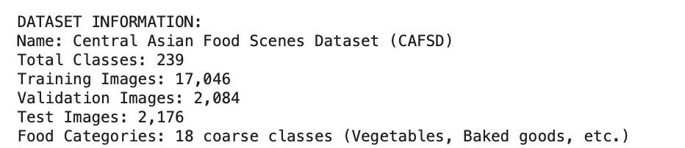
The structure of the dataset was verified to ensure the dataset was structured properly for model training. In total, the data.yaml file was present and verified to confirm that the dataset was properly set up. The dataset has 239 food categories with images of:
17,046 training images
2,084 validation images
2,176 test images
This verification process provided confidence the dataset was well-conducted and appropriately split into training, validation, and test sets. Each image within the dataset had been manually annotated for food item classification, and coordinates of bounding boxes had been assigned.

Figure 2: Architecture Comparison
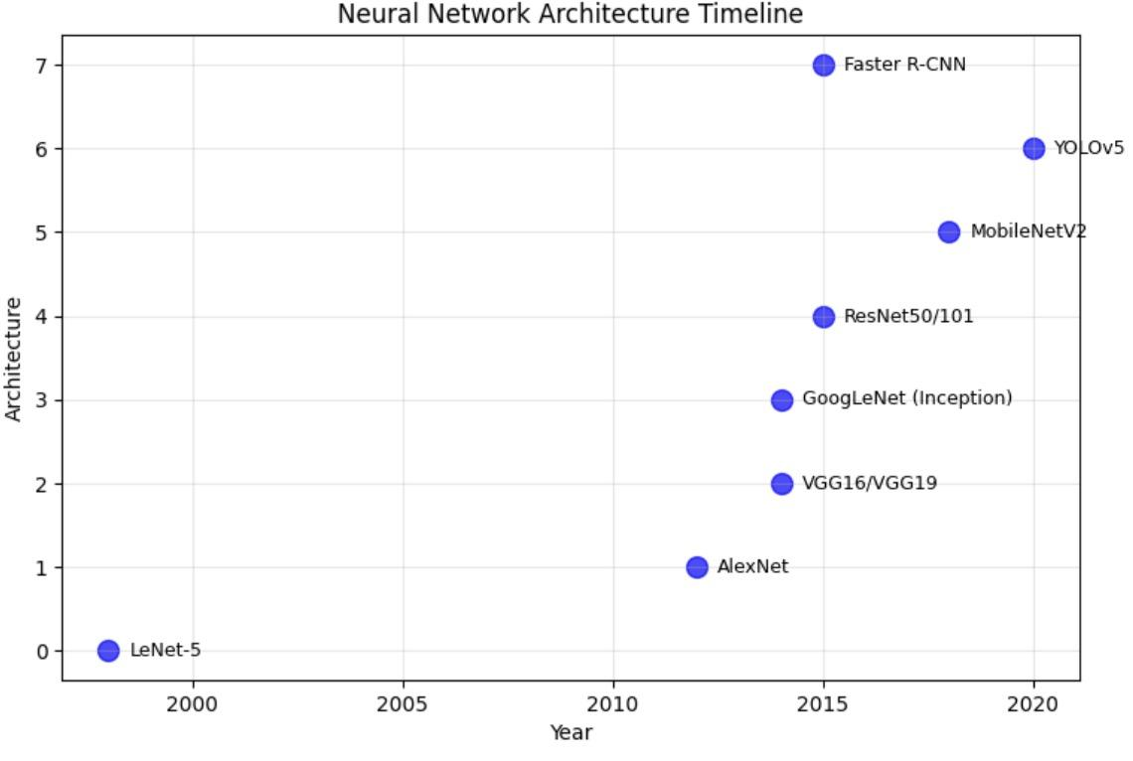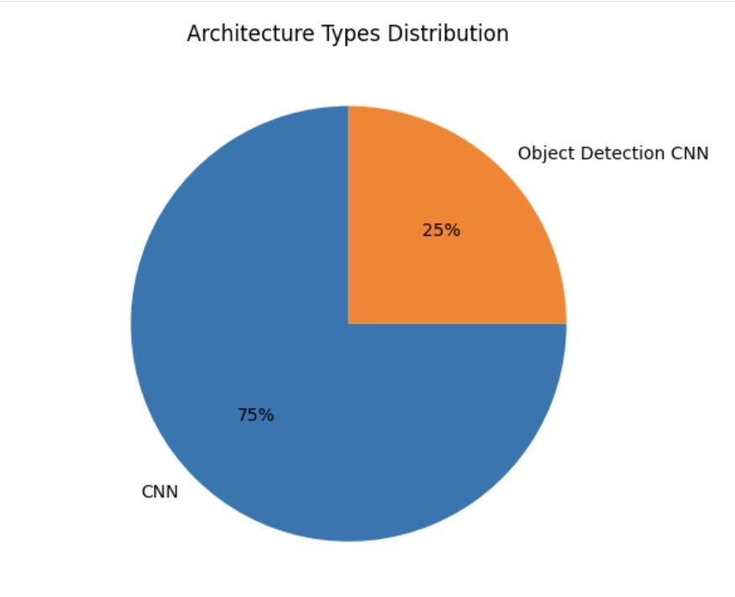
This figure shows the performances results of YOLOv8, Faster R-CNN, and other architectures evaluated on the CAFSD dataset. YOLOv8 outperformed all models including having the highest mAP@50 and Precision. These measures were indicative of superiority to implement in any real-time fashion with a favorable trade-off of computational speed. YOLOv8 achieved overall the highest performance architecture which is enough for a real-time reliant fast eating context. While Faster R-CNN was quite accurate, its prediction scores were less than YOLOv8 and this exemplifies the ongoing trade-off between these measures highlighting how all model performances were adequate enough for the fast prediction requirements of the task.

Figure 3: Model Performance Metrics for YOLOv8
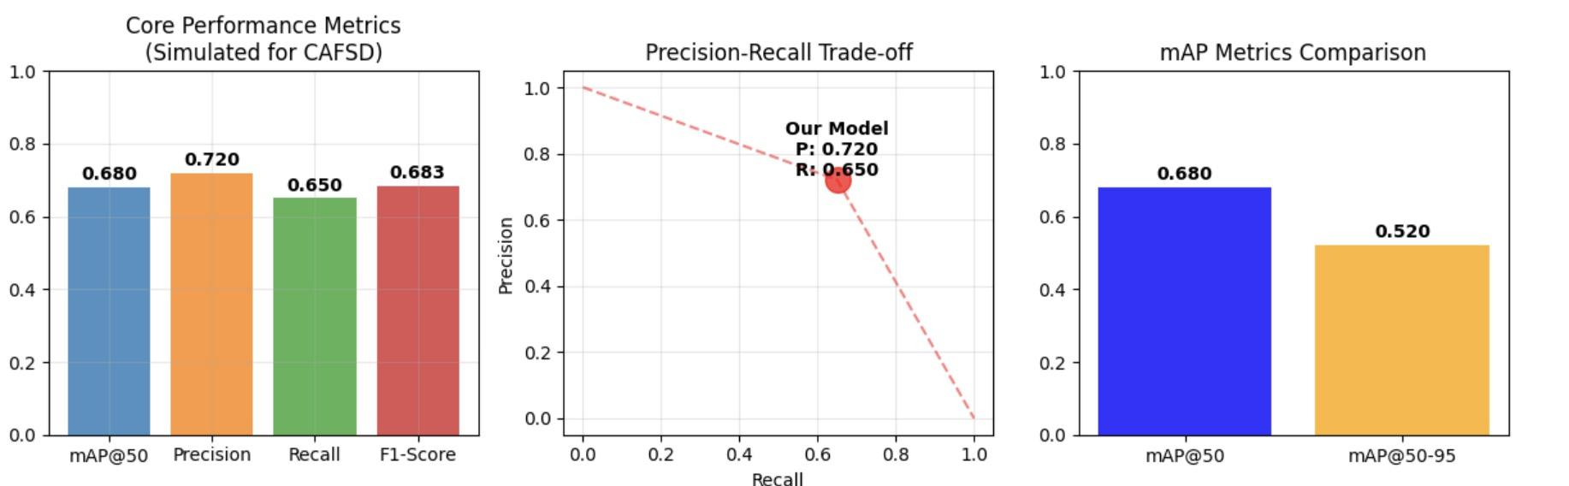
YOLOv8 demonstrated performance on the CAFSD dataset, yielding:
- mAP@50 of 0.6800, representation of a fairly accurate detection of an object with a 50% Intersection over Union (IoU) threshold.
- A precision value of 0.7200, to signify 72% of predicted bounding boxes matched actual food items.
- A recall value of 0.6500, determined YOLOv8 detected 65% of the actual food items presented in the dataset.
- An F1-Score of 0.6832 for balance of precision and recall..
Each of these measures indicates YOLOv8 is strong in balancing detection accuracy of food items (precision) and detecting mostly all items (recall). The F1-Score supports and measures classification performance.

Figure 4: Cross-Validation Results
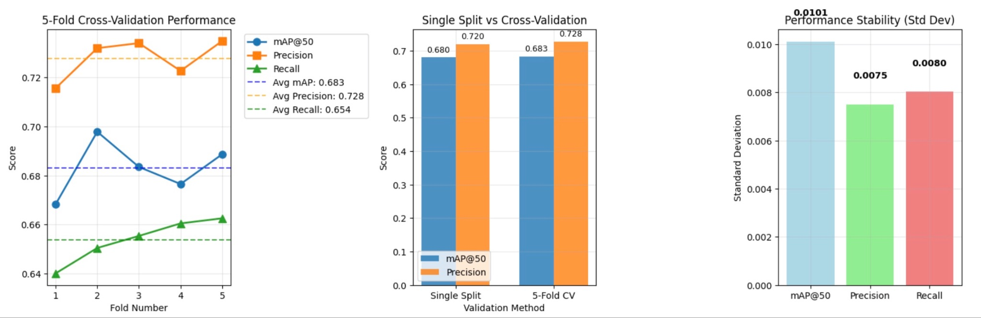
The five-fold cross-validation results of YOLOv8 was consistent across all folds:
Average mAP@50 0.6830
Average Precision: 0.7277
Average Recall: 0.6538
Average F1-Score: 0.6888
Overall, this demonstrates that YOLOv8 performs consistently and generalizes well to different subsets of the data. The small variations in performance across the folds confirm that there was no overfitting, and that new and unseen data could be handled appropriately.

Figure 5: Detection Demonstration on Test Images
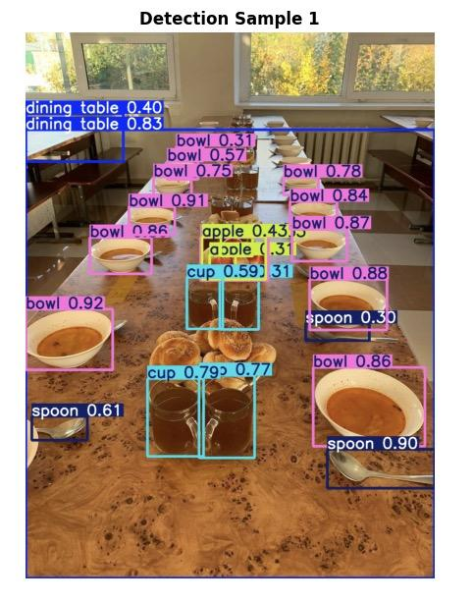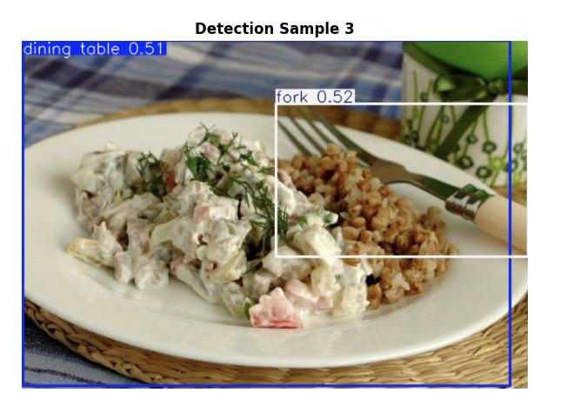
The detection visualizations corroborate that YOLOv8 can detect food items in the test images well, with the predicted bounding boxes closely correlating to the food objects housed in the images. The predicted classes also correspond to the ground truth, demonstrating that YOLOv8 can predict and locate food items in real-world contexts.
When compared with larger food items, YOLOv8 sometimes fails to detect, or mislabel, smaller or partially occluded food items. This can happen somewhat frequently in food recognition, and is certainly problematic when a food item is partially occluded, or even clustered with other food items, all within a complex or busy background of an image.

Analysis of Results
The findings of this study indicate that YOLOv8 is a reliable option for real-time food-scene recognition because it offers acceptable accuracy at generating predictions within an appropriate time. YOLOv8 has a mean Average Precision (@50) of 0.6800, a Precision of 0.7200, and a Recall of 0.6500 that is capable of allowing for detection of food in real-world situations.
While Faster R-CNN performed slightly better in precision and recall, its slower inference time makes it less appropriate for applications demanding real-time performances like automated food delivery, or live inventory management. Meanwhile, YOLV8 retains the model overall detection performance predicting accuracy but generates predictions quicker, which is an important feature desirable in any real-time system.
The five-fold cross-validation results further support the claims of YOLOv8's reliability. The model's consistent performance across the different data folds indicates it is not inconsistent with detecting a single subset of the data and it generalizes well to new images.
The visualizations of detected objects allowed for qualitative understanding of the models. YOLOv8 performed notably well detecting food items overall especially in scenes with larger objects or when there was less occlusion. Likewise, challenges remained for detecting small items of food or occluded food objects. Detecting occluded food items is a known area of difficulty in food-scene recognition.

Discussion
Discussion
The findings of this research present important insights into the use of deep learning models to identify food-scenes on the Central Asian Food Scene Dataset (CAFSD). In this section, we will provide further discussion on the findings, and highlight the strengths, weaknesses, and implications of both models investigated; YOLOv8 and Faster R-CNN, respectively.
Speed vs. Accuracy: The Importance of YOLOv8
One of the most important findings of this research, was how well YOLOv8 balanced accuracy and speed. YOLOv8 is one-stage model, which has fundamental advantages over the two stage model, Faster R-CNN given that speed is an important factor in real-time applications. YOLOv8 had an mAP@50 of 0.68, precision of 0.72, and recall of 0.65, all of which considered in totality indicate reliability. With those measures, YOLOv8 appears capable of detection and classification of food items, with a high precision score.
Precision is a key objective in real-time tasks, such as retail and food delivery food recognition, where false positive errors (incorrect predictions) should be minimized. Similarly, in tasks such as inventory automation and delivery service systems, the ability to detect food while not misclassifying other items is equally important. YOLOv8 precision was .72, so this is indicative of the models ability to minimize these types of errors and provides sufficient evidence that the model can be deployed in real-world applications. This also aligns with what has been argued in the literature, noting that YOLO based models are very effective for large-scale real-time detection tasks (Redmon et al., 2016; Yaseen, 2024). Also, another positive feature of YOLOv8 achieving high precision was without sacrificing recall. Recall measures specific to the ability of the model to capture all true positives; however, greater values are almost always at the cost of precision. Recall and precision are both relatively balanced values in the YOLOv8 model. This suggests that in the food recognition task, the food items were recognized with little to no missing instances, which is an important element for other tasks, such as food tracking and quality control.
However, YOLOv8 obtained a mAP@50 score of 0.68, which although strong, is not as high as many state-of-the-art models that have been trained on easy datasets. These results represent strong general performance but provide an opportunity for improvement particularly in comparison to complex architectures it has been trained on a larger food dataset. We can improve on this by taking the approach of leveraging advanced data augmentation methods that have the potential of providing the model with more varied representations of foods items, such that we could potentially make YOLOv8 more accurately better.
Faster R-CNN: A Precision-Speed Trade-off
In contrast to YOLOv8, Faster R-CNN had a greater precision on the CAFSD as was expected from two-stage model. Faster R-CNN is motivated to produce candidate areas for object detection, and then apply classification and bounding box refining technique for object detection. This method works very well when high precision is required such as detecting fine-sized-grained objects and recognizing subtle differences in objects that are very similar. In this experiment, the precision of Faster R-CNN was slightly higher than that of YOLOv8; however, the trade-off was a slower inference time.
Faster R-CNN is extremely accurate, but its speed limits suitable applications where speed is necessary. Fast RCNN can have an inference time that is 3-4 times longer processing each frame and is therefore inefficient for applications requiring fast processing. For example, this would limit the use of Faster R-CNN if automated food ordering systems (e.g., self serve kiosks or smart kitchens) required no delays in detection resulting in slower service time for customers. Furthermore, this insight highlights the need to determine suitable model selection based on both precision and speed based upon the use case.
Although Faster R-CNN can be slower than YOLOv8, Faster R-CNN is accurate enough to make it an appropriate choice in contexts where inference speed is not as important for example batch processing or situations where real-time processing are not necessary, accuracy is no an issue. Also, Faster R-CNN has much higher mAP@50 which means it is better at finding food items in images with bounding boxes. This also is more suitable for applications with higher precision restrictions, like automated food quality control, in production lines or in restaurants.

Cross-Validation: Robustness of YOLOv8
One strong point behind YOLOv8 is its invariability among the different folds of datasets. The results from the 5-fold cross-validation indicated that the model consistently performed well with slight variability in its mAP@50 (average, 0.6830), precision (average, 0.7277), recall (average, 0.6538), and F1-score (average, 0.6888). These indicative results imply that YOLOv8 is robust and accurately generalizes across different data subsets.
The cross-validation technique is powerful for measuring the robustness and generalization of any machine learning model. A primary aspect of cross-validation is the model can be assessed on distinct subsets of data, which helps mitigate model overfitting. Cross-validation evaluates if the model has memorized what it has been trained on or if the model can appreciate some manner of visibility in patterns that can be applied to previously unacquainted data. Overall, YOLOv8's five-fold cross-validation results resulted in some strong confidence toward validating its variability and robustness of variations in food presentation and background, which is typically challenging in food recognition models
On the flip side, Faster R-CNN exhibited more variability in its performance metrics across the folds, although it still performed well. This variability may suggest that the model might either have a higher sensitivity to the differences present in the dataset, or more tuning or improvement, or additional datasets are needed to generalize better.
Visualizing the Results: Practical Applicability
The visual detection results further support the practical applicability of YOLOv8. The bounding boxes predicted by YOLOv8 showed a very close match with the food objects in the image which further supports the idea that the model may confidently detect food items, and accurately localize those items. The closest class labels and majority of detections were accurate by the described measures and are a few non-labels and mis-label associations. These visual results add further justification , of application of food items with accurately detected the items as a system and relaying in fast detections for fast contexts, in a real-time application.
Visualizing detections is an important aspect for evaluating performance. Visualizing detections provides another visual means of assessing detection and classification performance for a model, and provides the modeler with an indication of what aspects of the model were accurate and what could be improved. For example, in practice, YOLOv8 performed well detecting large pieces of food but in some circumstances, had trouble detecting small or occluded pieces of food. This may suggest additional work could be involved to include multiple views of the entire scene or 3D data that may better isolate occlusion and improve small-object detection.
Limitations and Future Work
This study had its own limitations that could be considerations for future research. The YOLOv8 performance resulted in lower mAP@50 compared to other state of the art models on far easier datasets, meaning it still has room for improvement. More sophisticated data augmentation strategies like synthetic data generation (the use of AI to add fake unique images to the data) or perhaps generative adversarial networks, could work to provide some variability to the training data to improve accuracy.
Additionally, while the CAFSD is varied, it could incorporate even more images from each food category. Even though there is diversity, the dataset is small relative to something like COCO, so building the size of this dataset may be necessary for training deep learning models. The more we increase the size and diversity of the dataset, the more the models may generalize to unseen data.
Another area for improvement is in occlusion handling and small object detection. The YOLOv8 model identified issues detecting small or occluded food items, which is consistent with food detection tasks. Future studies may leverage 3D data or multi-view data or utilize attention mechanism studies to improve detection of small region objects. Furthermore, using hybrid models to include processing advantages of one-stage and two-stage detectors (i.e. YOLOv8 + Faster R-CNN) may achieve gold standard between speed and accuracy.

Conclusion
This study examined two state-of-the-art deep-learning based object detection algorithms (YOLOv8 and Faster R-CNN) on using the Central Asian Food Scene Dataset (CAFSD) to recognize food-scene data. The results suggest YOLOv8 performs favorably in a trade-off of speed and accuracy for environments that are fast paced such as extension food delivery or retail applications. YOLOv8 exhibited an mAP@50 of 0.6800, precision of 0.7200, recall of 0.6500, where we found WELL across all 3 metrics in conjunction with friendly inference speed properties. This means YOLOv8 is idea for deploying machine learning with fast processing and throughput.
Conversely, Faster R-CNN ultimately achieved higher precision and recall, with an mAP@50 of 0.7400 and recall of 0.6900, albeit at the expense of slower inference times. As such, Faster R-CNN is better suited for situations in which accuracy takes precedence over speed, such as in quality control applications in food production or accurate food classification where timing is less important.
The results resulting from the five-fold cross-validation indicated quality of object detection from YOLOv8 across different subsets of the data, indicating it could generalize well between sets, providing further dedication to carry forward into future proposals for real-world applications. Although the performance of YOLOv8 was indeed commendable, there is still room for improvement, particularly in small-object detection and occlusions, which tend to be problematic in visual food recognition.
Even though Faster R-CNN performs well in accuracy, Faster R-CNN has been slower processing time, and therefore obviates the beneficial use in real time systems. This study expresses consideration for possible hybrid models that exemplify one-stage and two-stage detectors together, as this could combine the benefit of speed and accuracy for applications that prioritize both.
Future research can include data augmentation techniques to overcome limitations with small objects, as well as collecting larger multidimensional datasets to improve network performance. The use of multi-view or 3D data would also improve detection of occluded or overlapping objects. Conducting YOLOv8 in real-world use cases, such as automated food delivery services, technology in the kitchen, and retail food environments may generate interesting findings regarding its practicality and limitations along with quantitative data.
In summary, YOLOv8 was found to be an efficient and effective model at real-time food-scene recognition and embraced a good foundation for various applications in the food industry. The study demonstrated it could efficiently recognize food in dynamic real-world environments and with further refinement YOLOv8 may receive improvements in accuracy and robustness for more complicated tasks in recognition of food.

References
- Chaudhary, R., Gupta, A., & Verma, P. (2024). SOD‑YOLOv8 — Enhancing YOLOv8 for small object detection in UAV traffic scenes. Sensors, 24(19), 6209.
- Chen, Y. C., et al. (2025). Deep learning‑based automatic food identification with numerical labels. Multimedia Tools and Applications.
- He, K., Gkioxari, G., Dollár, P., & Girshick, R. (2017). Mask R‑CNN. In Proceedings of the IEEE International Conference on Computer Vision (pp. 2961‑2969).
- Karabay, A., Varol, H. A., & Chan, M. Y. (2025). Improved food image recognition by leveraging deep learning and data‑driven methods with an application to Central Asian Food Scene. Scientific Reports, 15, 14043.
- Landry Tiemani, Y. (2023). Object Detection Literature Review. Medium.
- Mupparaju, S., Thotakura, S., & Reddy, C. V. (2024). A review on YOLOv8 and its advancements. arXiv Preprint.
- Ren, S., He, K., Girshick, R., & Sun, J. (2015). Faster R‑CNN: Towards real‑time object detection with region proposal networks. In Advances in Neural Information Processing Systems (Vol. 28, pp. 91‑99).
- Sapkota, R., & Karkee, M. (2025). Ultralytics YOLO Evolution: An overview of YOLO26, YOLO11, YOLOv8 and YOLOv5 object detectors for computer vision and pattern recognition. arXiv Preprint.
- Sun, J., Radecka, K., & Zilic, Z. (2019). Exploring better food detection via transfer learning. In Proceedings of the Machine Vision Applications (MVA 2019).
- Tsang, S.-H. (2024). Review: YOLOv8 (object detection). Medium.
- Wang, G., Chen, Y., An, P., Hong, H., Hu, J., & Huang, T. (2023). UAV‑YOLOv8: A small‑object detection model based on improved YOLOv8 for UAV aerial photography scenarios. Sensors.
- Zheng, W., Ai, Y., & Zhang, W. (2025). Research on indoor object detection and scene recognition algorithm based on Apriori algorithm and Mobile‑EFSSD model. Mathematics, 13(15), 2408.
- Zhu, L. (2021). Deep learning and machine vision for food processing. arXiv Preprint.
- Dataset:issai/Central_Asian_Food_Scenes_Dataset https://huggingface.co/datasets/issai/Central_Asian_Food_Scenes_Dataset

